Execution Report – Booking API POST /places

Contents

1.Executive summary 2

2.Functional testing – Postman collection 2

3.Performance testing – JMeter (100 Threads × 5 min, 30 s ramp) 3

4 Idempotency test – Postman 4

5.Database-consistency check – JMeter 4

6.KPI Performance 4

7.Recommendations & priority 5

8.Attachments / evidence 5

10.Assumptions & limitations 5

# 1.Executive summary

* **Always-201 behaviour.** The endpoint returns **201 Created** for any JSON Valid or invalid, giving a functional pass-rate of **2 / 4 (50 %)**.
* **Performance OK.** load test (100 VU, 5 min, 30 s ramp) meets the SLA (**95-percentile = 0 .53 s ≤ 2 s**).
* **Key defects.**
  + No server-side field/date validation.
  + No uniqueness / idempotency enforcement on (user_id, place_id).

# 2.Functional testing – Postman collection

|  |  |  |  |  |
| --- | --- | --- | --- | --- |
| TC # | Scenario | Expected HTTP | Actual | Result |
| 01 | Valid payload | 201 | 201 | Pass |
| 02 | Empty-string fields | 400 | 201 | Fail |
| 03 | Invalid date format | 400 | 201 | Fail |
| 04 | Large & special IDs * | 2xx / 400 | 201 | Pass |

Runner outcome: **2 pass / 2 fail** (Booking API Tests.postman_test_run.json).

# 3.Performance testing – JMeter (100 Threads × 5 min, 30 s ramp)

|  |  |
| --- | --- |
| Metric (valid requests only) | Value |
| Samples | 97 |
| Avg. response time | 467 ms |
| 90-percentile | 521 ms |
| 95-percentile | 533 ms |
| Max | 652 ms |
| Throughput | 3.3 req/s |
| Error % (valid) | 0 % |
| Error % (overall)* | 3.96 % |

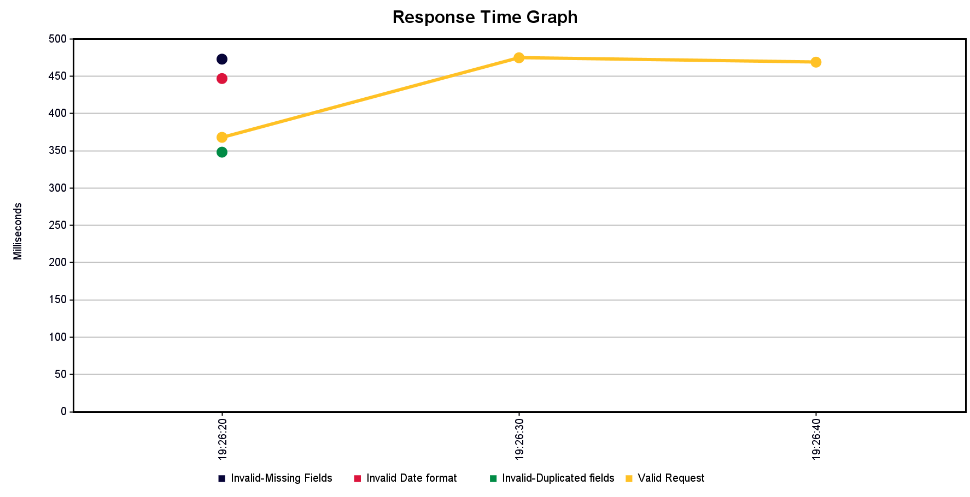

*The Overall Error is related to Invalid-input samplers fail their assertions (still receive 201).  
Documents : summary.csv, aggregate.csv, result.jtl, plus screenshots.

# 4 Idempotency test – Postman

|  |  |  |  |  |
| --- | --- | --- | --- | --- |
| Step | Request | Expected | Actual | Status |
| 1 | POST /places (payload A) | 201 | 201 | **Pass** |
| 2 | Repeat payload A | 409 Conflict | 201 | **Fail** |

Runner export: Test Idempotency.postman_test_run.json.

**Finding:** duplicates are inserted instead of returning 409.

# 5.Database-consistency check – JMeter

|  |  |
| --- | --- |
| Variable | Value |
| createdCount (successful POSTs) | 7 |
| id_matchNr (rows from GET /places) | 7 |
| JSR223 assertion | **PASS** |

Counts align ⇒ no lost writes, but duplicates/invalid rows remain because validation is missing.

# 6.KPI Performance

|  |  |  |  |
| --- | --- | --- | --- |
| KPI | Target | Result | Status |
| Latency (95 %) | ≤ 2 s | 0.53 s | **Pass** |
| Error rate (valid) | < 3 % | 0 % | **Pass** |
| Idempotency | Duplicate → 409 | 201 | **Fail** |
| Missing Input validation | Reject empty / bad → 400 | Accepts →201 | **Fail** |
| DB consistency | POST = GET count | 7 = 7 ** | **Pass** |

# 7.Recommendations & priority

|  |  |  |
| --- | --- | --- |
| Priority | Root-cause | Recommendations |
| P0 | **No server-side field/date validation** → empty strings & bad dates accepted. | Implement value validation |
| P0 | **No uniqueness constraint** on (user_id, place_id) → duplicates succeed. | Add DB unique index or application check → return **409 Conflict** on duplicates. |

# 8.Attachments / evidence

|  |  |
| --- | --- |
| File | Description |
| Booking API Tests.postman_test_run.json | Functional-suite results |
| Test Idempotency.postman_test_run.json | Duplicate-booking evidence |
| Bonus-Database summary.csv, Bonus-Database aggregate.csv, Database consistency result1.jtl |  |
| Load Test summary.csv, Load Test aggregate.csv, Load Test result.jtl | Raw JMeter metrics |
| summary_report.png, aggregate_report.png, results_tree.png | Performance screenshots |

# 10.Assumptions & limitations

* Endpoint is a **MockAPI** instance; latency in production may differ.
* Load test ran from a single machine; no network variance simulated.